DECA ICDC
Info Packet
DECA’s International Career Development Conference supports education initiatives such as:
- Career Clusters
- National Curriculum Standards
- 21st Century Skills
- Common Core State Standards
- Project-based Learning
The National Association of
Secondary School Principals

- Personal Financial Literacy

In this packet you will find the 2017 DECA ICDC Registration Information. You will be emailed an Excel Spreadsheet for registration. The ICDC Conference is

Dates: April 25-30

Email back by March 22 the Excel Spreadsheet to pjgrethel@hotmail.com.

Mail your spreadsheet list of attendees and your school check to pay for your non-refundable deposit ($100/person) by
March 22 (postmark). The remainder of the money is due by
April 21. No late registrations will be accepted.

Teachers: Bring the Conduct and Permission Forms (pages 3-5) with you
to ICDC. Keep them in your possession.

Each state has a limited hotel allotment. We will fill our room allotment as completed chapter orders arrive. Keep in mind that if we run out of rooms, those schools that registered later could end up at another hotel if we can’t get additional rooms through national DECA.

If you have any students with special needs, please contact Paul Grethel for a form to fill out.

ICDC CONFERENCE PRICING

ICDC in Anaheim: The prices on the last page of this packet include DECA registration, 5 nights in a hotel, conference t-shirt, insurance, and trading pins, light up item, OR 4 nights plus the other items. An adult is required for every 8 minors attending.

Louisiana DECA has been assigned to the Anaheim Marriott Hotel, 700 W. Convention Way, Anaheim, CA 92802. This is 1 block to the Convention Center.

Registration Form: After the state conference, you will receive via email an Excel spreadsheet to use to register. Each registrant must submit a $100 non-refundable deposit per person by March 22 (postmark). Email by March 22 your Excel spreadsheet with names of who will be attending ICDC and mail your check made payable to Louisiana DECA. Be sure to put in all beneficiary info with each registrant. By April 22 the entire amount due will be due and everything for this conference will be paid for by La. DECA by that time. Encourage your students who make a commitment to attend, to carry through or make sure you tell them they will owe the entire amount.

Promissory Note: It is highly recommended that if you are extending any form of credit to your students for this conference that you use the “Promissory Note” which can be found on another page of this packet. This is a legal document and should be signed by any student 18 or older. If the student is under 18, then both the student and the parent should sign it. This will protect you and any funds you put forth.
If you would like a copy of a letter that your students can use to obtain donations from businesses, let me know. All a student needs to do is go after several $25-$50 donations in order to attend. A business or a person can make a check out to the school and get a tax deduction.
La. Competition Rules: A 1st, 2nd or 3rd place team from CDC can use substitute players to complete the team who is going to ICDC; however, anyone used as a substitute MUST have attended CDC. Students can only compete in one event or workshop at ICDC.

CODE OF ETHICS FOR ADULT ADVISORS

DECA offers training to those students who have a career objective in the field of marketing, finance, hospitality, management or entrepreneurship. Individual conduct and appearance is a phase of this training. This phase of the education program becomes apparent at DECA’s International Career Development Conference.

Since a good example is one method of teaching, and students participating in the conference are impressionable, a Code of Ethics is set for adult advisors.

It becomes the responsibility of each and every participant to see that proper conduct is adhered to at all times. Violations of these practices and procedures will be referred to the president of the Board of Directors for DECA Inc.

- Advisors shall conduct daily meetings with participants for progress reports, time schedules and other activities.

- Advisors shall keep an agenda for each student so that they may be reached at any time during the conference.

- Each state/province shall arrange to have one advisor on call at all times.

- Each advisor shall be responsible for seeing that participants adhere to all conduct practices and procedures.

- The rules as stated in the Delegate Conduct Practices and Procedures and the Dress Code are called to your attention for review and should govern the behavior of advisors as well as students.
DELEGATE CONDUCT PRACTICES AND PROCEDURES

The Board of Directors for DECA Inc. requires each delegate attending the International Career Development Conference to read and complete the Attendance Permission Form and return to the state/provincial DECA advisor as partial completion of attendance requirements.

- The term “delegate” shall mean any DECA member, including advisors, attending conferences (high school, collegiate, alumni, professional).

- There shall be no defacing of public property. Any damage to any property or furnishing in the hotel rooms or building must be paid for by the individual or chapter responsible.

- Delegates must wear identification badges and wristbands at all times.

- Delegates shall refrain from using inappropriate or profane language at all times.

- Delegates shall refrain from verbal, physical or sexual harassment, hazing or name-calling.

- Delegates shall respect the rights and safety of other hotel guests.

- Delegates shall not possess alcoholic beverages, narcotics or weapons in any form at any time under any circumstances.

- Delegates shall refrain from gambling—playing cards, dice or games of chance for money or other things of value.

- Use of tobacco products by delegates is prohibited at all DECA functions.

- Delegates must adhere to the dress code at all times.

- Delegates must not dress or behave in a manner than can be interpreted as sexually explicit.

- Students shall keep their adult advisors informed of their activities and whereabouts at all times.

- No delegate shall leave the hotel (except for authorized events) unless permission has been received from chapter and state/provincial advisors.

- Delegates should be prompt and prepared for all activities.

- Delegates should be financially prepared for all activities.

- Delegates are required to attend all sessions and activities assigned including workshops, competitive events, committee meetings, etc. for which they are registered unless engaged in some specific assignment scheduled at the same time.

- Delegates will spend nights at their assigned hotel and in their assigned room. No guests allowed during curfew hours. Delegates will be quiet at curfew.

- Curfew will be enforced. Curfew means the delegate will be in his/her assigned room.

- State/Provincial associations will be responsible for delegates’ conduct.

- Delegates ignoring or violating any of the above rules will subject their entire delegation to being unseated and their candidates or competitive events participants to being disqualified. Individual delegates may be sent home immediately at their own expense.

- Tasteful casual wear will be accepted during specific social functions as designated during orientation.

INTERNATIONAL CAREER DEVELOPMENT CONFERENCE
LOUISIANA ATTENDANCE PERMISSION FORM

DRESS CODE FOR ICDC Approved by the DECA Board of Directors, August, 2009

From the opening session until the end of the closing session, students, advisors and professionals shall adhere to the following Dress Code requirements. It is the Chapter Advisor’s responsibility to see that their students and all professionals with the rules established for proper dress code. Advisors should monitor their students’ dress at all functions. Professional business dress should be worn to all events where a judge or observer may be in attendance. This will include participating events as well as testing. Business representatives, press personnel, hotel staff and guests will be seeing DECA’s finest members—show them a professional business image.

Competitors must wear an official DECA blazer during interaction with judges. While you do not have to wear an official DECA blazer during briefing and testing, professional business dress is required.

PROFESSIONAL BUSINESS ATTIRE | WHEN APPEARING BEFORE JUDGES

Females
- Official DECA blazer with dress skirt or dress slacks and a dress blouse or official DECA blazer with a dress
- Dress shoes (no tennis shoes or flip-flop sandals)

Males
- Official DECA blazer with dress slacks, collared dress shirt and necktie
- Dress shoes (no tennis shoes or flip-flop sandals) and dress socks
DECA GENERAL SESSIONS | WORKSHOPS | MEAL FUNCTIONS

Females
- Business suit or blazer with dress blouse and dress skirt or dress slacks or business dress
- Dress shoes (no tennis shoes or flip-flop sandals)

Males
- Business suit or sport coat with dress slacks, collared dress shirt and necktie
- Dress shoes (no tennis shoes or flip-flop sandals) and dress socks

An official DECA blazer is required to receive recognition/an award on stage.
EVENT BRIEFING | MANUAL REGISTRATION & TESTING | LEADERSHIP ACADEMIES | INSTITUTES
Females
- Dress blouse or dress sweater with dress skirt or dress slacks (blazer optional) or business dress
- Dress shoes (no tennis shoes or flip-flop sandals)

Males
- Collared dress shirt and necktie with dress slacks (blazer optional)
- Dress shoes and dress socks
DECA BUSINESS CASUAL
- Casual slacks, blouse or shirt, socks and casual shoes
- Jeans, t-shirts and athletic shoes are NOT included in business casual attire.
THE FOLLOWING ARE UNACCEPTABLE AT DECA EVENTS:
- Skin-tight or revealing clothing
- Midriff-baring clothing
- Leggings or graphic designed hosiery/tights
- Clothing with printing that is suggestive, obscene or promotes illegal substances
- Athletic clothing
- Swimwear

ATTENDANCE

This is to certify that has my permission to attend the above named DECA activity. I also do hereby on behalf of him/her absolve and release the school officials, the DECA chapter advisors and the assigned chartered association DECA staff from any claims for personal injuries or illness which might be sustained while he/she is en route to and from or during the DECA sponsored activity.

I understand that DECA activities may occur as late as midnight and that the City of Nashville has a curfew of 11 p.m. I am authorizing my child’s DECA advisor and/or chaperone to take my place in accompanying the DECA member for a designated period of time and purpose within a specified area. Furthermore, I understand that after the curfew, my child may travel directly to the hotel without detour or stop from an official DECA activity with the supervision of the DECA advisor.

EMERGENCY

Any medical exceptions to this code must be documented in the conference headquarters prior to the beginning of the conference. This is the responsibility of the local advisor.

I authorize the advisor to secure the services of a physician or hospital, and to incur the expenses for necessary services in the event of accident or illness, and I will provide for the payment of these costs:

We have read and agree to abide by the DECA Code of Conduct. We also agree that the school officials, the DECA chapter advisors, the chartered association DECA staff, or the Conference Conduct Committee members have the right to send

home from the activity at our expense, provided that he/she has violated the Code of Conduct and/or his/her conduct has become a detriment.

Student Signature

Parent/Guardian Signature Phone

Chapter Advisor Signature School Official Signature

Insurance Company Name Policy Number

PROMISSORY NOTE

I, ____________________________________, agree to pay the DECA Chapter of ___________________ High School the amount of $__________ by ___________ (due date), for monies paid for _____________________ (student’s name) by the school’s DECA Chapter. These funds are being paid to Louisiana DECA for the _______________ Conference.

I understand that $______ in grant funds were used to pay part of this conference. I agree to reimburse the chapter for these funds if ________________ (student’s name) misses the conferences.

I understand that there is no interest charged to borrow this money as long as I pay it back by the due date; however, a five percent (5%) compound interest penalty will be imposed for each 1-30 days I am late with this payment after the date above.

My signature, along with my parent’s signature (if I am a minor) signify that I will pay this amount on or before the due date.



DECA Student Signature________________________________ Date______________

Parent’s Signature______________________________________ Date______________
(if student is under 18 years old)

Teacher’s Signature_____________________________________ Date_____________

(Parents—keep a copy of this for your records.)

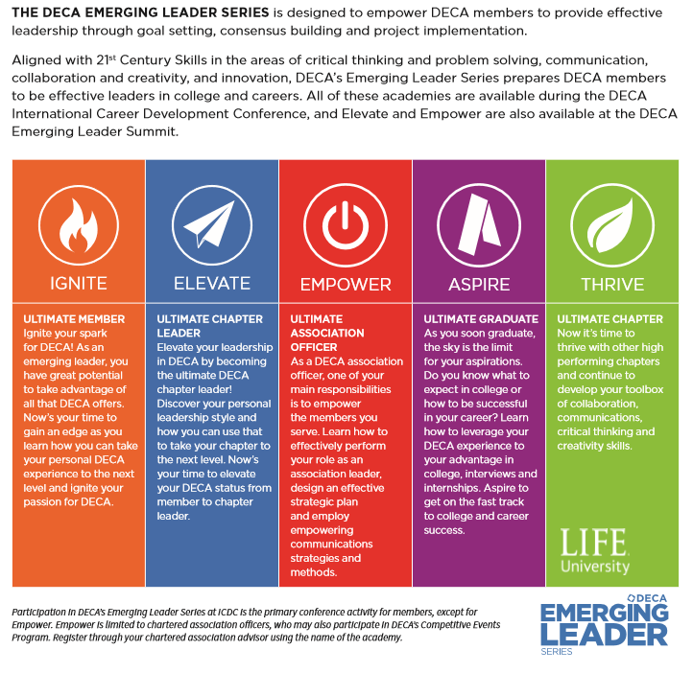

These workshops would be for those students who did not place in the top 3 at the state conference but who want to attend ICDC since everyone who attends ICDC must be in either a competitive event or a workshop. Only those who attended CDC are eligible to attend ICDC and only if room is available.

 |  | Lodging & Registration  Price Per Person  5 nights  April 25-30 | Lodging & Registration  Price Per  Person  4 nights
LODGING & REGISTRATION  The prices include DECA registration, 5 nights in a hotel, conference t-shirt, insurance, and trading pins/lighted item.  Review the tours on page 3.  You must order them at  http://www.deca.org/icdc  Flights are to be arranged and paid for by the student or advisor | State Officer (DECA pays Nat. DECA registration and lodging; officer pays rest) | Student pays for transportation, meals & tours | Student pays for transportation, meals & tours
 | Single Room for 1 – there are a very limited # of single rooms available | $1345 | $1130
 | Double – 2 beds for 2 people | $820 | $670
 | Triple—2 beds for 3 people | $640 | $560
 | Quad—2 beds for 4 people | $550 | $490

After the state conference, I will email you an Excel Spreadsheet to fill out in order to register. Return it via email to pjgrethel@hotmail.com by March 22, then mail a $100 non-refundable deposit per person by March 16 (postmark). Encourage your students who make a commitment to attend, to carry through or make sure you tell them they will owe the entire amount.

The remaining balance is due by April 21, 2017.

